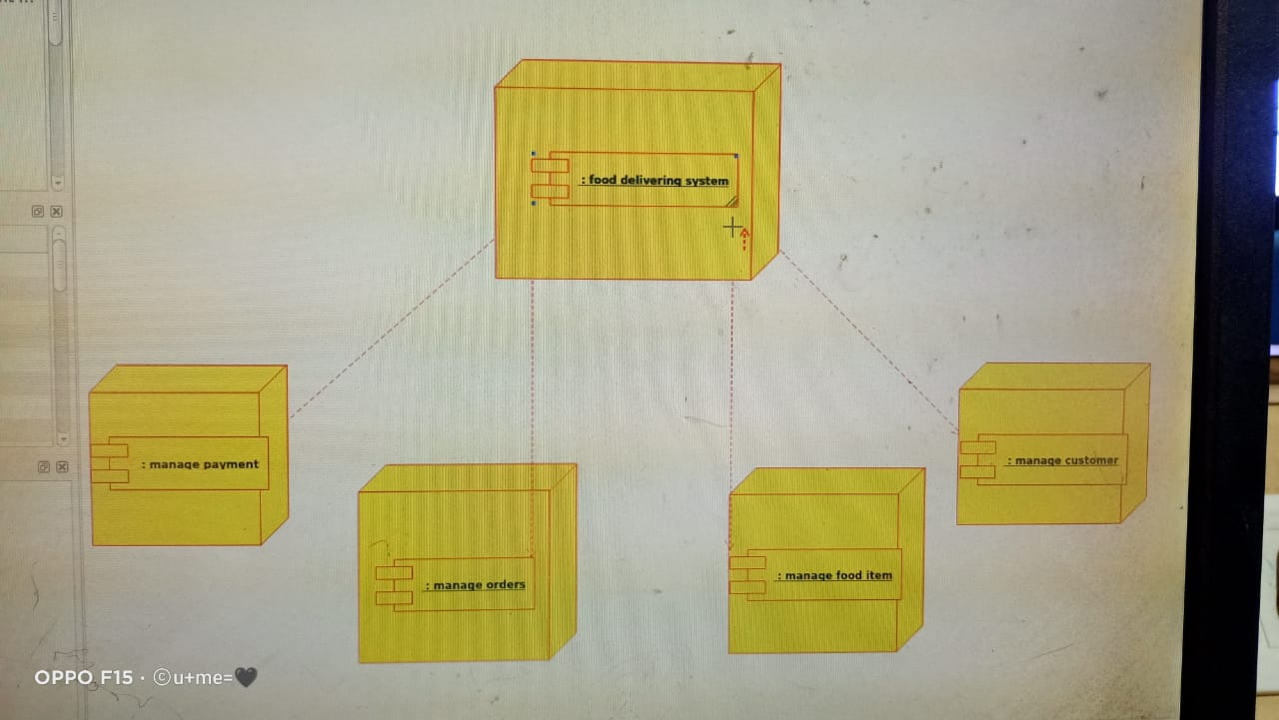

DEPLOYMENT DIAGRAM

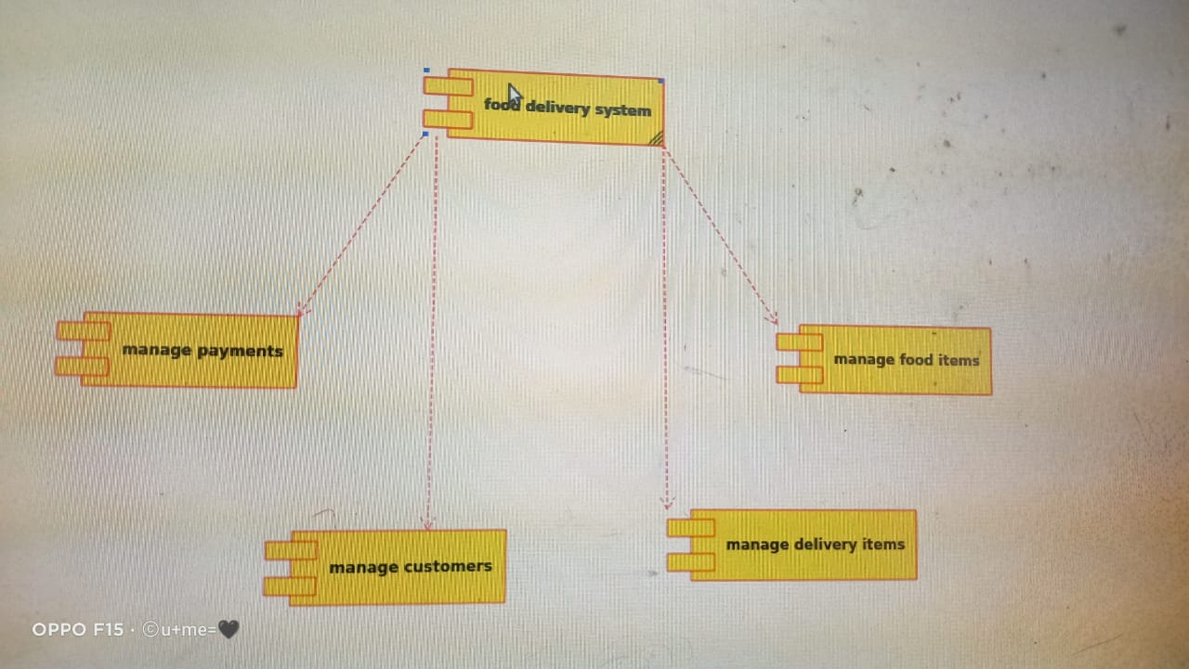

COMPONENT DIAGRAM

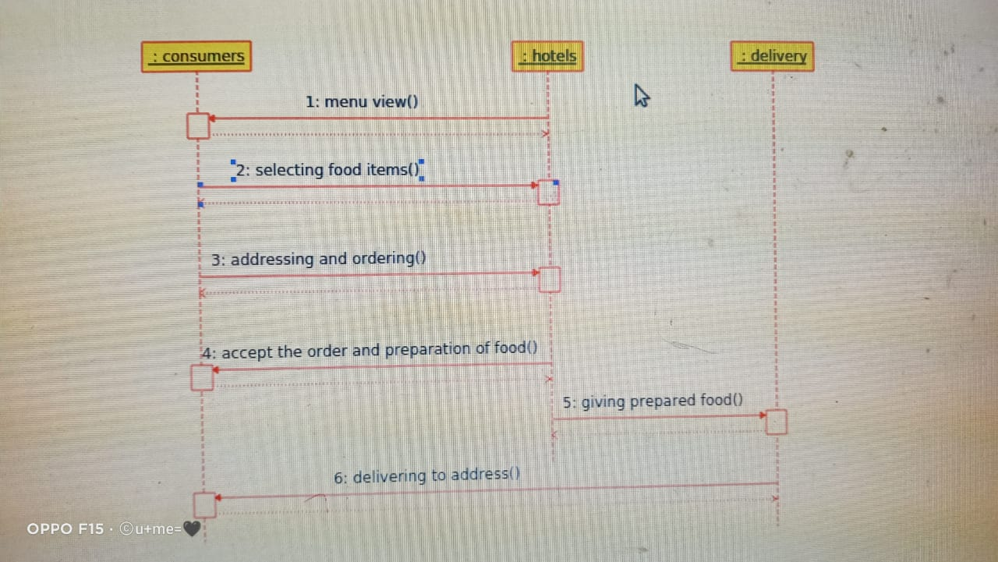

SEQUENCE DIAGRAM

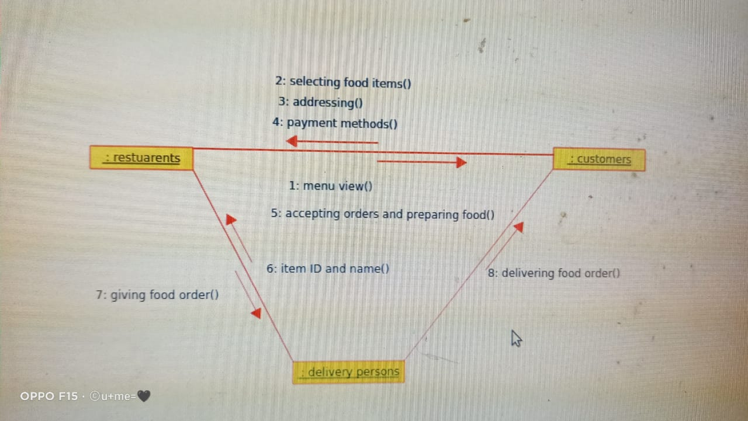

COLLABORATION DIAGRAM

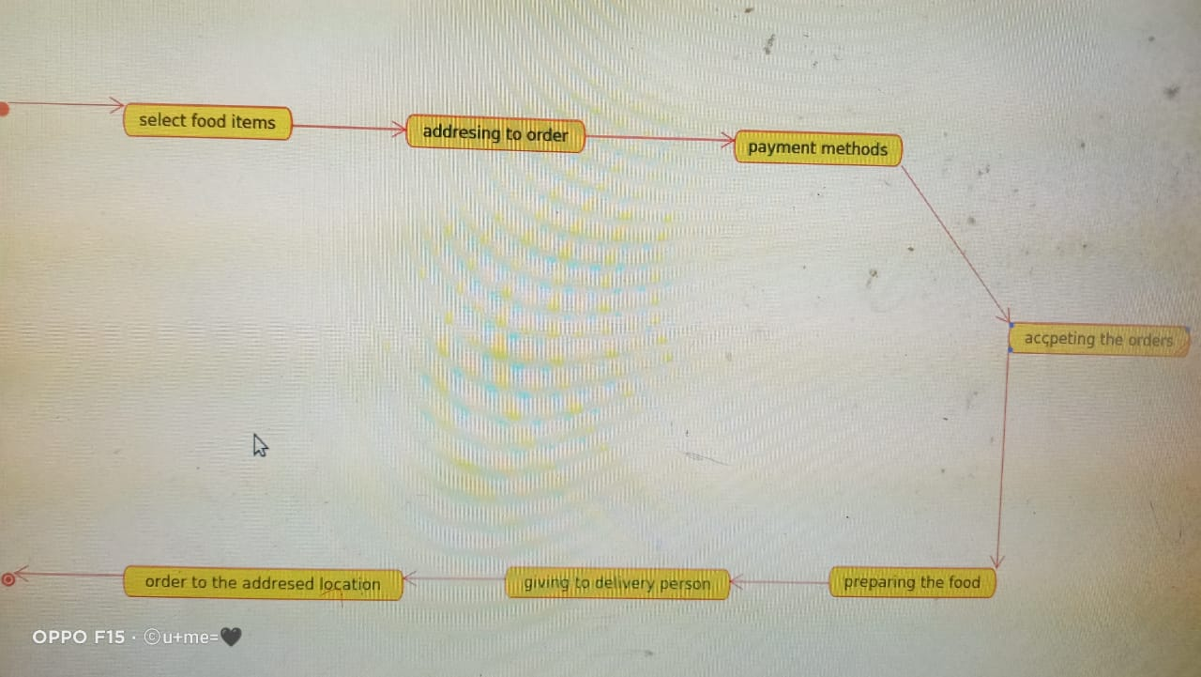

STATE CHART DIAGRAM

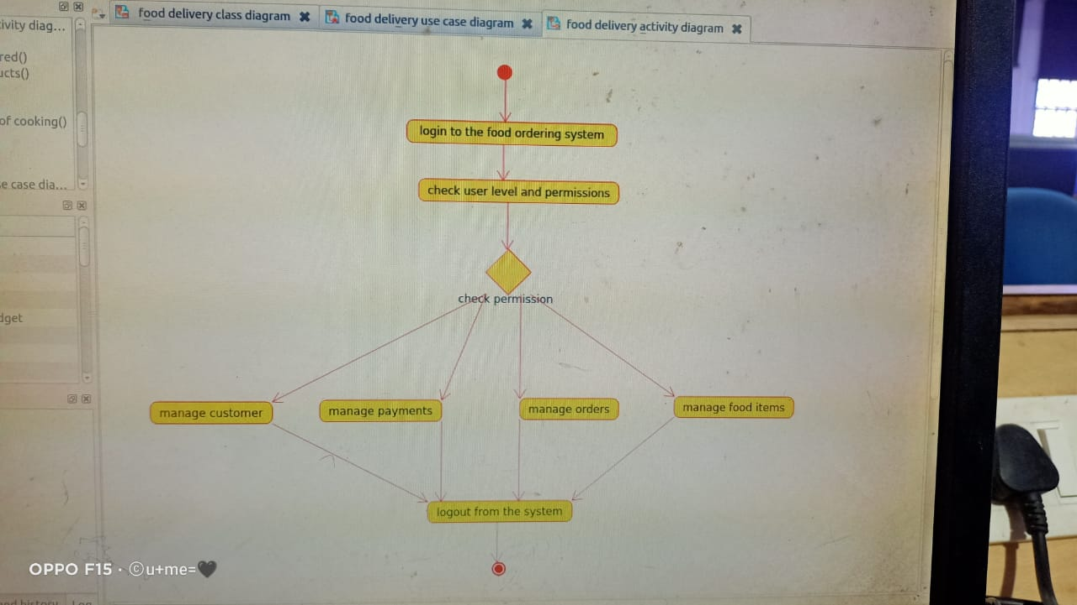

ACTIVITY DIAGRAM

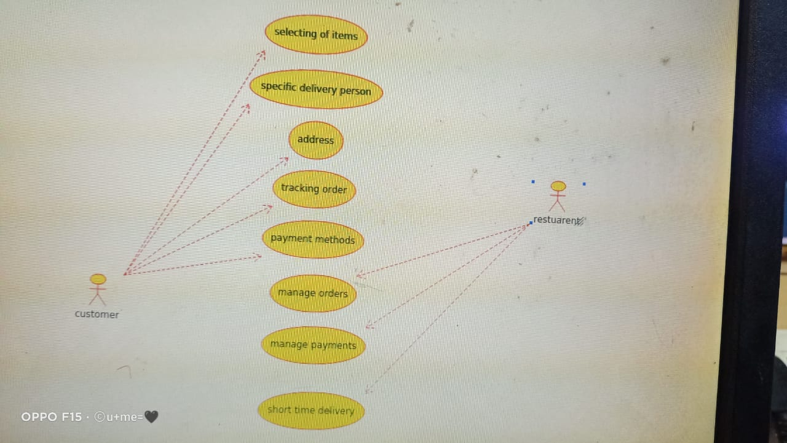

USE CASE DIAGRAM

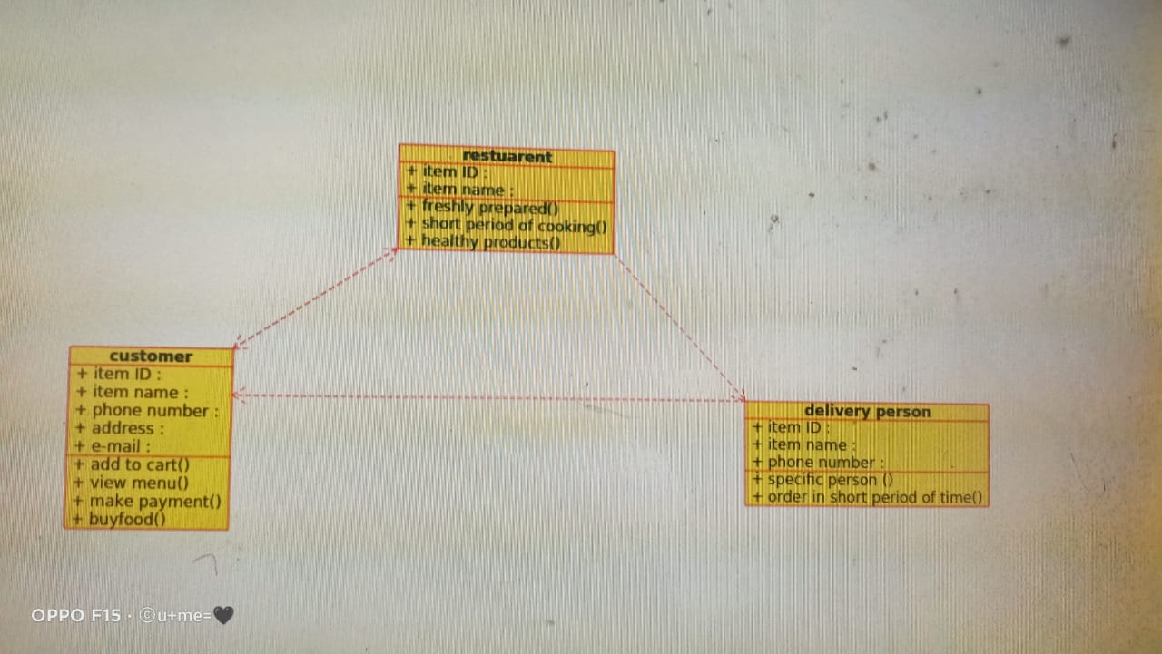

CLASS DIAGRAM

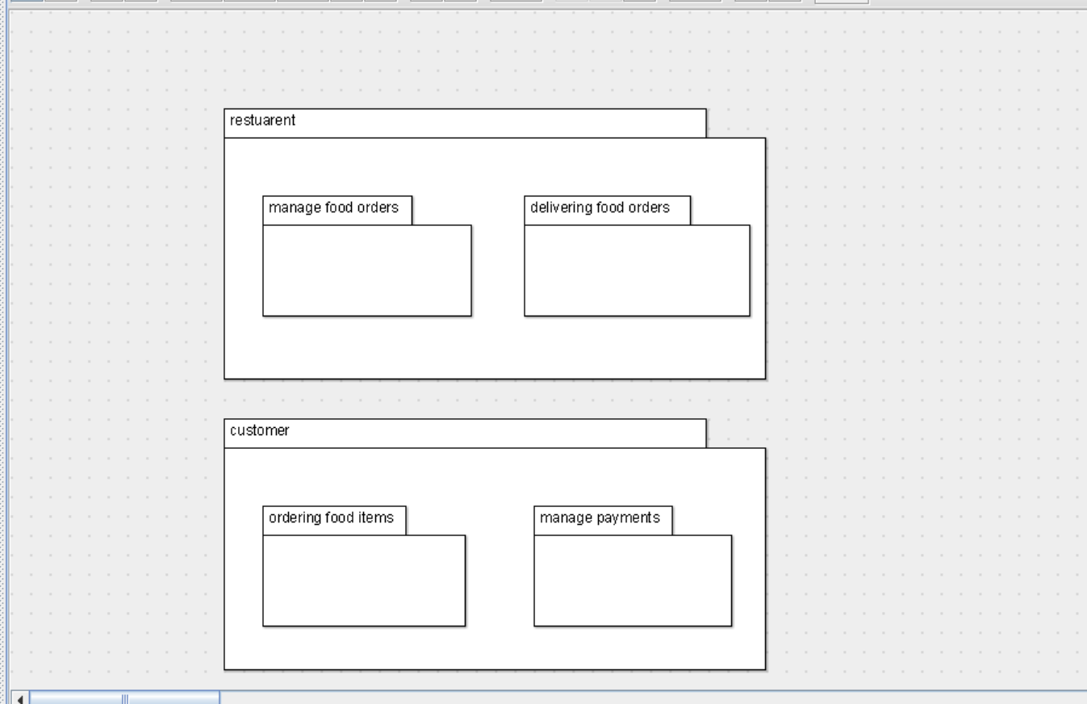

PACKAGE DIAGRAM

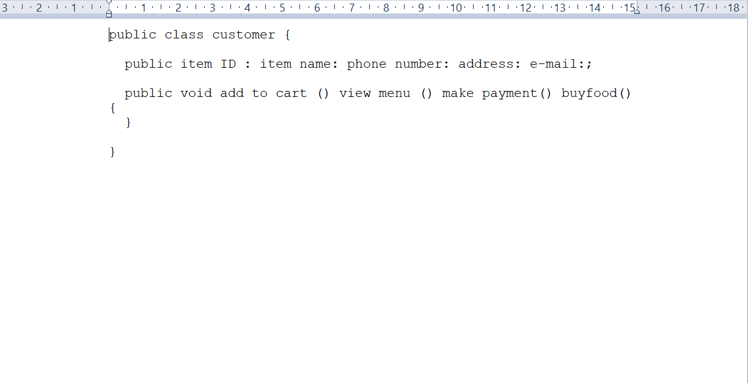

CUSTOMER SKELETON CODE

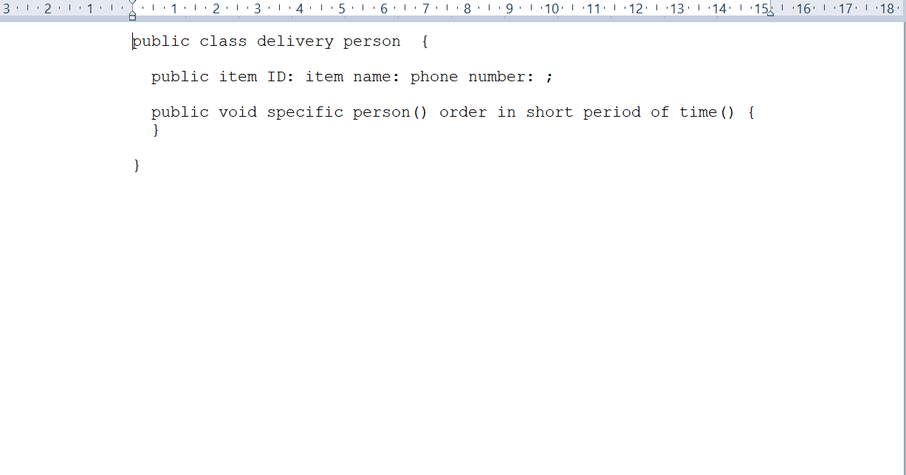

DELIVERY PERSONS SKELETON CODE

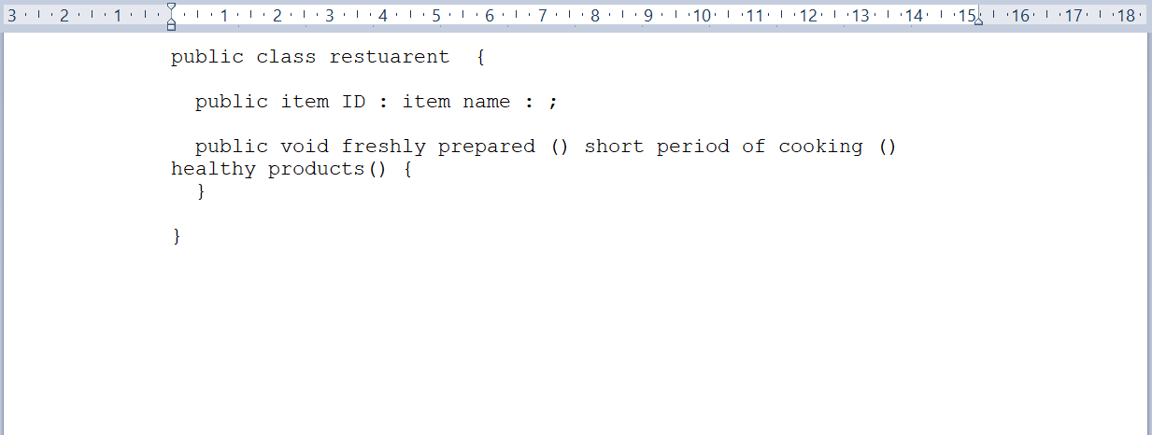

RESTUARENT SKELETON CODE